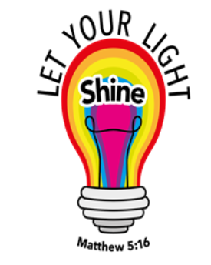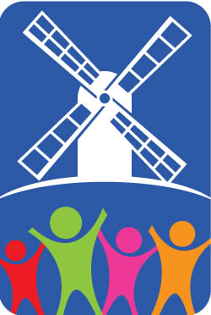

Kibworth Primary School

Year 6: Summer 1

Revolution

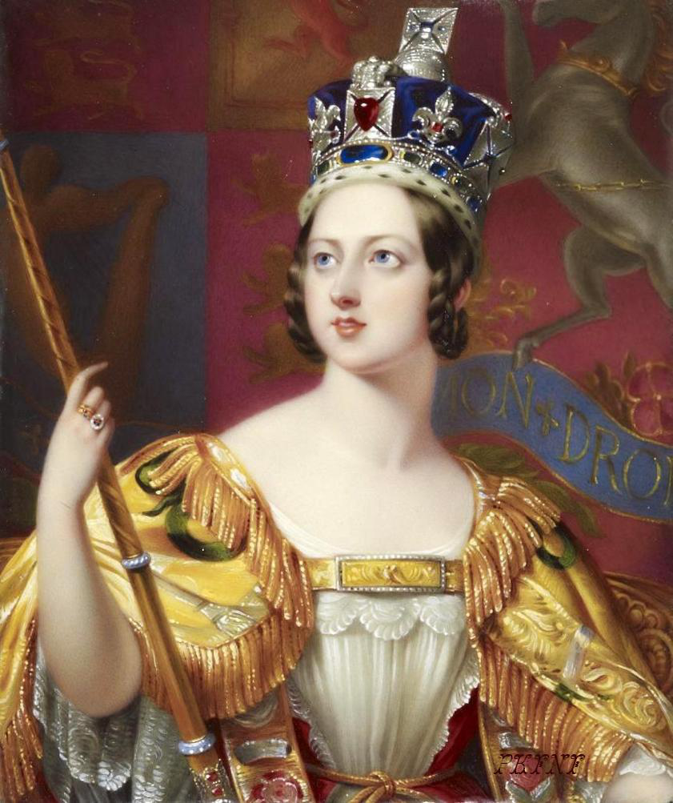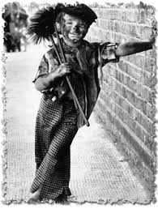

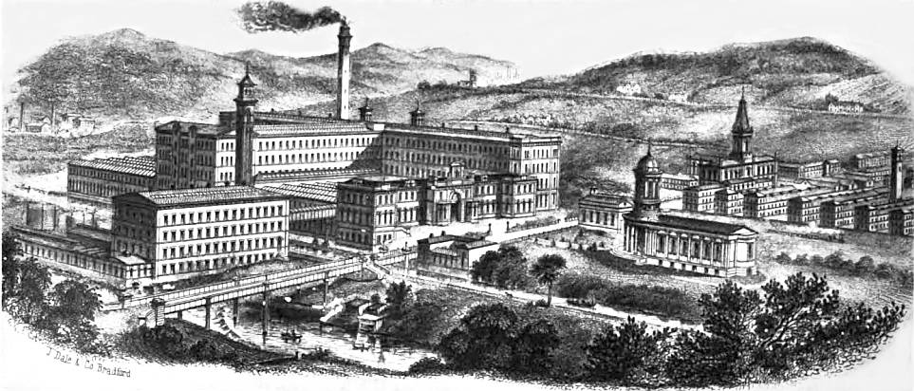

Dear Parents/Carers,

Welcome back after the Easter holidays! Ahead of us is one of the most important terms of Year 6. All of the hard work that the children have put in before Christmas and over home-schooling really comes together and we begin to see great progress in their learning. As we enter the summer term, we will begin to start re-visiting many areas of the Year 6 curriculum to ensure that the children are confident with their learning. Alongside this, in topic, we will be looking at a really interesting time in British history: the Victorian era with a focus on the British Revolution and the impact on the world. This will provide a great opportunity for children to learn about what life was like during the Victorian period for a range of people, the working laws as well as how the revolution shaped our country.

|  |  |
| --- | --- |
| **Literacy** | |
| **Narrative to Entertain** | **Discussion** |
| Image result for oliver twist book  Children will re-visit their skills in using dialogue to add description, develop character and advance the action. They will investigate and read examples of narrative from the Victorian era such as Oliver Twist and Street Child to develop an understanding of language and character. Children will then re-write a section of Charles Dicken’s Oliver Twist applying all their skills. They will focus on using dialogue to infer differences in character as well as advancing the action within a story. | Children will re-visit discussion writing, looking at purpose, structure and formality. In topic, we will be learning about the different jobs that children would have had during the Victorian times and will then write a discussion that identifies whether child labour should have been made illegal in the first part of the 19th Century. |
| **Maths** | |
| **Algebra, Ratio and Proportion, Investigations and Consolidation** | |
| Children will begin the term with new mathematical learning: algebra. They will learn how to substitute values into algebraic expressions, find the values in algebraic expressions, find multiple possibilities that satisfy algebraic equations and practise writing their own algebraic expressions.  Following this, children will learn about ratio and proportion. They will understand what these key mathematical terms mean and how to solve related word problems understanding how they link to real life problems.  Throughout the term, children will also explore some investigative maths projects applying their previous knowledge on skills learnt throughout the year. They will conduct their own lines of enquiry, conjecture and spot relationships between numbers and patterns. For the final part of the term, children will re-visit all of their mathematical learning from the year in order to ensure that all areas have been consolidated. | |

**Key areas of learning:**

|  |  |  |
| --- | --- | --- |
| **Science** | **History** | |
| Light   * Know that light appears to travel in straight lines * Know how objects are seen by the eye * Know that light travels from light sources to the eye * Know that shadows have the same shape as the object that cast them | The Victorians   * Know when the Victorians started and ended * Know where they come in relation to other historical periods * Know what was life like for children during the Victorian period: Mining, factories, chimney sweep * How society changed – introduction of Education act * How thanks to Victorian times, children are now educated in school and no longer expected to work * Compare this to modern day children still working * How slavery impacted the world * How Britain’s revolution impacted the world | |
| **Art** | **Computing** | **R.E** |
| Printing   * Know how to create printing blocks by using a simplified idea * Know the difference between relief and impressed method * Know how to create prints with three overlays | Graphical modelling   * Independently select the most appropriate ICT tools for intended purpose and audience. * Routinely evaluate and improve work as part of the design process. * Use a range of digital devices to produce digital ‘content’. | What can be done to reduce racism   * Pupils have opportunities to consider the concept of diversity * Pupils have opportunities to consider a diverse range of views about questions of living together, tolerance and respect and prejudice-reduction * From the study of beliefs and values in different religions and worldviews, pupils will be able to think about their own experiences and views about race, ethnicity and racial justice in relation to religions and worldviews. |

|  |  |
| --- | --- |
| **Week 1: Who were the Victorians?** | |
| See the source image | In this first week, children will explore chronology and investigate when the Victorians were in power in Britain. Children will then learn about the importance of Britain around the world at this time and explore which countries made up the British Empire. |
| **Week 2 and 3: What was slavery?** | |
| See the source image | In these two weeks, we will discuss what triangular trade was and learn more about the slave trade and how it financed the growth of industry in Britain over the 18th and 19th centuries. We will learn what life was like on plantations for slaves in the Caribbean. Finally, we will learn about the abolitionists, such as William Wilberforce, that fought for the end of slavery in the 19th Century. |
| **Week 4: What was the Industrial revolution?** | |
| Image result for industrial revolution | Children will learn about the changes that took place over the course of the Victorians in particular the Industrial Revolution. They will learn how due to the invention of machinery, factories spring up across the whole of Britain, bringing in people from the countryside to the towns. |
| **Week 5 and 6: What jobs did children have in the Victorian times?** | |
| See the source image | Over these two weeks, children will learn about child labour during Victorian times. They will explore the different jobs that children were involved in and what conditions were like at this time. The children will then look at social reform and the laws that were brought in to ensure that all children received an education. |
| **Week 7: Modern Day Child Labour** | |
| Image result for modern day slavery | Having learnt about the social reformations that took place in the 19th Century in Britain to end child labour and make education compulsory for children, we will look at how child labour is still taking place around the world today. We will learn about the different jobs that children are having to complete in some countries to earn money to support their families. |

Thank you for your continued support and if you have any questions, please do not hesitate to come in and speak to one of our team.

Mr Roantree, Miss Cornish and Miss Hyman

**Things that you could do at home**

* Please continue to support your children with their reading at home. Even in Year 6, it is still really important that children continue to practise reading out loud in order to discuss their book or to check unknown words.
* Times tables are key in maths and rapid recall of these supports many key areas; please continue to encourage your children to practise these at home. We will have times table races every week at school to practise.

**Here are a few websites that may help to support your child’s learning during his half term.**

**Maths:**

Century – All children have their log in details in the front of their homework books

Interactive games to practise times tables

<http://www.oswego.org/ocsd-web/games/mathmagician/mathsmulti.html>

Maths activities

<http://nrich.maths.org/frontpage>

**Literacy:**

Grammar

<http://www.ks2phonics.org.uk/Clausesandconnectives.html>