Kibworth C of E Primary School
Year 5
Summer Term 2021
Egypt
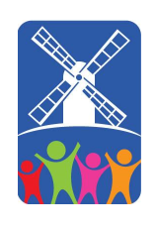
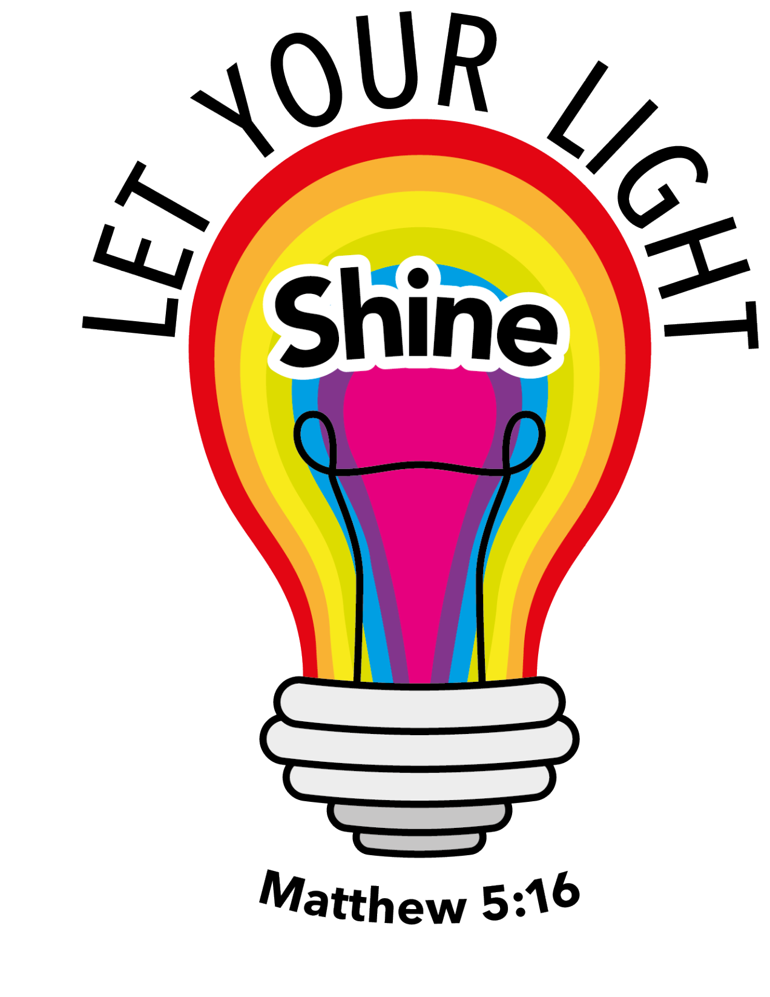

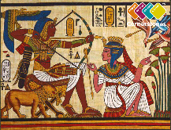

Dear Parents and Carers,

It’s hard to believe we are in our final term of Year 5! We hope you had a lovely Easter holiday and are feeling refreshed for an exciting term of learning. Last term was an interesting one and we are all so proud of how well you all coped with the constant changes. This term, we are travelling across seas (not literally) to learn about all things Egyptian. It is a fun-filled and knowledge packed topic which we know you will all love. We are looking forward to sharing our learning with you again.

Literacy
Throughout our literacy learning this year, we are going to be learning about how to write for a range of purposes. Our focus for this term is writing to entertain. We will also be doing a reading unit in our literacy lessons.
Adding well-chosen detail: Diary Entries | Reading: The Highway Man.
We will consolidate our learning of cohesion and adding detail in this unit whilst developing our knowledge of narratives. Children will learn how to add extra detail using a range of punctuation and powerful adjectives. The skills we will focus on are dashes, brackets, adverbials and developing character. | In this unit, children will develop their inference skills when unpicking this famous poem and look at how the poet impacts the readers moods and emotions through the use of figurative language and powerful vocabulary. Children will then have a go at applying this learning to write their own verses to recite to others.
Mathematics
Geometry and measurement | Fractions, decimals and percentages.
Children will continue to build on their learning from Year 4 and from before Easter to consolidate finding the perimeter of rectilinear shapes and then we will move onto finding the areas of these shapes. | Children will learn what percentages are and how to find a percentage of an amount. Furthermore, children will also learn how to convert fractions into decimals or percentages and vice versa.

Key areas of learning:
Science
Children will finish off their science learning from before the Easter Holidays about the properties of different materials and how we can group and classify them.
Moreover, children will also learn about the key stages of growth in humans and changes that take place in our bodies as we start to grow up.

Outline of Learning Journey
Week 1 – Engage! | This week we will engage in our topic by participating in a treasure hunt Egyptian Quiz. We will also spend this week immersing ourselves in topic specific vocabulary and learning how where the Egyptians fit into the historic timeline.
Week 2 – Mummification and After Life. | The afterlife was incredibly important for the Egyptians and we will explore how they treated people who passed. In addition, we will explore what was in store for Egyptians once they pass and the Gods they will hopefully (or not) meet.
Week 3- The Egyptian Gods. | The ancient Egyptians had a vast number of different Gods for all areas of their lives. We will learn about some of the most significant ones and explore how these are different gods of other historical periods.
Week 4 – Mapping Egypt. | In this week, we will become geographers and explore how Egypt has changed over time. Additionally, we will be zooming in to the River Nile to identify its main features.
Week 5 – The importance of the River Nile. | We will discuss the importance of the River Nile for Ancient and modern Egyptians.
Week 6 – Express! | This week we will be expressing all of our Egyptian learning to share with others.
Week 7 – Prayer Spaces. | Along with our friends from Saint Wilfrid’s Church

Things that you could do at home:
- Watch Horrible Histories.
- Research Hieroglyphics and write a secret message to a friend.
- Research death masks and create your own.

Here are a few ideas of how you can support your child’s learning at home this half term:

• Use Times Table Rockstars to practice rapid recall of times tables. https://ttrockstars.com/login

• Consolidate reading learning at school by using my Rising Stars.

• Continue to help your child practise their weekly spellings set each Monday on Teams.

• Use the handwriting videos we have created on Teams (find in the handwriting channel).

•Follow your child’s suggested learning path on Century.

• Continue to support your child’s reading and recording of reading at home. Encourage them to discuss what they have learnt from their reading: this may be through clarifying unknown vocabulary or answering the types of questions we shared with you at parents’ evening.

Thank you so much for your continued support. We are looking forward to a fun-filled half term.

Miss Parrott, Mr Swingler, Miss Baker, Mrs Cording, Miss Craven, Miss Withers and Miss Lafferty.
Year 5 team

