
Kibworth Primary School
Year 2: Spring 2 and Summer 1 2021
Curriculum Information
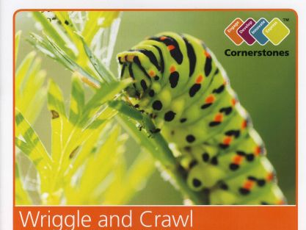

Wriggle and Crawl
Dear Parents/Carers,

Our next topic has a scientific focus where the children will engage with creatures in their local environment and investigate their habitats.
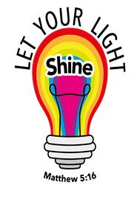
General reminders about Year 2.

Reading folders should be brought into school every day. Please read with your child every day and record any reading your child does at home in their diaries. The school’s Reading Raffle takes place on a Friday, so it is important that children have their diaries in school so they can be entered into the raffle.

Homework will continue to be given out weekly on a Friday and is expected to be completed and back to the teacher by the following Wednesday. This gives us time to mark their homework and get their new work in. Any issues with this then please speak to their class teacher.
Reading
Non Fiction
The children will be retrieving information about different insects from non-fiction texts and fact files. They will learn to use a contents page, glossary and index to know their way through non-fiction books.

Fiction
The children will be reading and listening to ‘Superworm’ by Julia Donaldson. They will be using our reading characters to encourage them to skim and scan for key words, find clues in the text and clarify the meaning of new words.

- Word detective: Draw on knowledge of vocabulary to understand texts.
- Investigator: Identify/explain key aspects of fiction and non-fiction texts, such as characters, events, titles and information.
- Clue Finder PAST: Make inferences from the text.
- Clue Finder FUTURE: Predict what might happen on the basis of what has been read so far.
- Spotter: Identify and explain the sequence of events in texts.

Writing
This term we will be consolidating the writing skills that we have learnt throughout the year and introducing apostrophes to show something belongs to somebody (possession). We will be writing using conjunctions to join ideas together (and, but, or, if, when, that, because) and working on expanding our vocabulary to write narratives based around ‘Superworm’. They will also be learning to write for different purposes; writing minibeast fact files using the features of a non-fiction text e.g. headings, sub-headings, factual vocabulary, labelled diagrams etc. The children will continue to develop their cursive script and make sure all letters are formed correctly, starting and finishing in the correct place, and ensuring long ladder letters and capital letters are tall.

Maths
In Maths, the children will be learning all about money, shape and time. They will consolidate their subtraction skills by working out the change given in money problems and they will be comparing the properties of 2D and 3D shapes. We will be introducing time and talking about sequencing events in a day. We will look at how many hours are in a day and minutes in an hour. We will then continue to learn to tell the time at 15-minute intervals (o’clock, quarter past, half past and quarter to). There will be a focus on consolidating and applying all the calculation (+, -, x, ÷) and fractions learning that the children have done throughout the year.

Science | Living things and their habitats | In this topic, the childre will be identifying the basic needs of plants and animals for survival, observing how beans and caterpillars grow and understanding the life-cycle of plants and animals. Throughout which they will be learning new scientific vocabulary such as: herbivore, carnivore, omnivore, predator and prey. They will investigate how animals are adapted to their habitat and get the chance to create their own creature with features to help them live underwater.
RE | Celebrations and Holy books | In Religious Education the children will be thinking about everything that they celebrate and how they can be celebrated. They will develop an understanding of importance of some Christian and Muslim celebrations for example Easter and Eid-ul-fitr.  Children will also be looking into the importance and purpose of Holy books. They will compare stories from the Bible to the Qur’an and discuss what holy books can teach people on how to live their lives.
PE | Dance/Gymnastics  Outdoor games | In these sessions the children will continue to perform movements to express ideas.  They will master basic movements including running, jumping, throwing and catching, as well as devloping balance, agility and coordination.
Art | Observational sketching | The children will develop their sketching skills and use line, shape, pattern and texture to draw accurately. They will sketch trees and plants from around the school and use detailed photographs to sketch a minibeast.
D&T | Design, Make and Evaluate Minibeast Hotels | Children will design their own minibeast hotel following a design criteria. They will then make it and evaluate its’ effectiveness for the insects, using their knowledge of what living things need to survive.

If you have any questions or concerns, please do not hesitate to contact us.

Miss Morley, Mrs Winston, Miss Mason
Mrs Sharp, Ms Hodgetts, Ms Jones and Mrs Donoghue-Parker
The Year 2 Team

