
Kibworth Primary School
Year 2: Autumn Term 2 2020
Curriculum Information
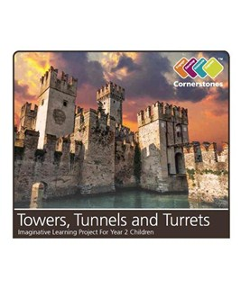

Towers, Turrets and Tunnels

Dear Parents,
We hope that you had a very happy and peaceful break and that the children are ready to start a new term of learning and fun. We think the children will all be excited and enthused by our new topic of Towers, Turrets and Tunnels.
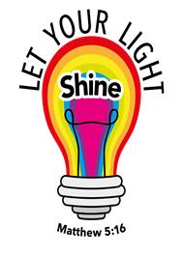
We will begin the half term by learning all about the ‘Battle of Hastings’ and the life of William the Conqueror.
We will re-enact the battle using our new knowledge and debate on the behalf of both opponents. We will also learn about castles by exploring all their features in order to become castle experts.

Below is an idea of some of the knowledge your child will learn and use in the coming half term.

English
Non – fiction Posters  The children will be looking at information texts to learn all about castles by reading for meaning and retrieving key facts. We will be exploring how authors write to inform and how to create clear posters to share knowledge about the features of a castle. | Fiction - Narrative  ‘The Paper Bag Princess’ by Robert Munseh  The children will be reading ‘The Paper Bag Princess’ and exploring the new vocabulary it includes. We will then be learning how to write correctly in the past tense be adding the suffix –ed to the end of words. We will also learn how to link ideas by using conjunctions (and, but, or) to make our writing flow. We will apply all these skills to create our own retell of ‘The Paper Bag Princess’.
Reading
The children will use ‘‘The Paper Bag Princess’ to develop their understanding of narratives by asking and answering questions about the story. They will also build on their prediction skills; deciding what might happen next.
During guided reading sessions, the children will continue to develop their decoding and sight reading skills. We will really be encouraging the children to read fluently by recognising as many high frequency words as they can and using their segmenting and blending skills to decode unfamiliar words.
We will focus on re-reading texts where necessary so the children gain a secure understanding of what they have read and are able to retrieve simple answers.

Maths
At the beginning of this term we will be ensuring that our number bonds to 10 and consequently 100 are secure and continue working on the fluency of counting in our 2, 5 and 10. After this, our main focus will be addition and subtraction. First we will work mental methods to add and subtract smaller number by counting on and backwards. Then we will continue with adding and subtracting 2-digit numbers, using practical resources, number lines, hundred squares and a simple column method.

History | The Battle of Hasting and Castles | The children will gain key knowledge of the significant historical event – ‘The Battle of Hastings’ and explore the life of William the Conqueror. They will identify and understand the features of castles as well as their importance as a form of defence.
Computing | E-Safety  Coding | The children will continue to learn about e-safety in preparation for accessing the internet later in the year. They will also be continuing their learning about coding and programming, using iPads and begin to understand and construct simple algorithms, using the program ‘code.org’.
RE | Christmas | The children will learn about the Christian celebration of Christmas and consolidate their knowldge on the story behind the celebration. We will be investigating the following key questions:  How do Christians celebrate Christmas?  How are Christians stories connected with Christmas?
Music | Christmas Play  Kibworth Creatives | This year, although we will not be able to have a live performance, the children will learn and perform their part for the Christmas play. We are excited for them to record this so you will be able to watch along at home.  The children will continue to be taught music lessons by ‘The Kibworth Creatives’ and they will be practising the songs and actions to improve their listening and performance skills.
PE | Mastering  Multi skills | PE lessons will continue to be on a Wednesday and Thursday afternoon, so please remember to come dressed in your PE kit. The lessons will continue to be taught outside (weather permitting) so it is really important that children are warmly dressed.
DT | Castles  (Sheet Materials) | The children will follow the design process by designing, exploring, making and evaluating their very own castle to fit a specific design brief. They will work on their cutting and joining skills to create hinges and simple pop ups.

If you have any questions or concerns, please do not hesitate to contact us.

Miss Morley, Mrs Winston, Miss Mason
Mrs Sharp, Ms Hodgetts, Ms Jones and Mrs Donoghue-Parker
The Year 2 Team

