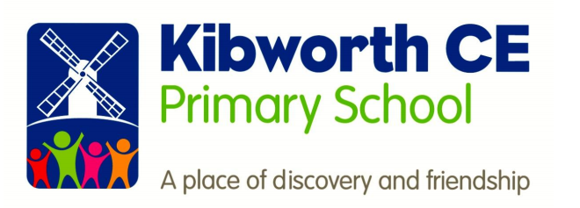

Phonics

This policy was approved as follows:
Adopted by: |  | Date:
Review Date: |  | Review frequency: | 3 yearly

Rationale & Intent
This policy outlines the teaching, organisation and management of the phonics taught and learnt at Kibworth Church of England Primary School.

At Kibworth C of E Primary School we strive to ensure that all children become successful, fluent readers by the end of Key Stage One and believe this is achievable through a combination of strong, high quality, discrete phonics teaching combined with a whole language approach that promotes a ‘Reading for Pleasure’ culture.
The Rose Report (2006) emphasised high quality phonics as an important part of the word decoding skills required by children to develop higher level whole language and comprehension skills. This approach is in alignment with our belief that we first ‘learn to read’ and then ‘read to learn’.
This policy is aimed at reinforcing a consistent, high quality approach to the teaching of phonics across the Early Years Foundation Stage, (EYFS,) Key Stage One and on into Key Stage Two for children who still need this further support.

Role of coordinator:
- To be enthusiastic about phonics and demonstrate good practices.
- To work alongside colleagues in planning where needed (progress and activities).
- To work alongside teachers in the classroom (this will depend on release time and other available help).
- To coordinate and arrange staff in-service training as required.
- To audit resources,
- To manage the phonics budget.
- To “sample” the work of children across the age range (curriculum monitoring).
- To review and evaluate the effectiveness of teaching and learning of phonics.
- To provide guidance on the implementation of the phonics policy.
- To suggest appropriate assessment activities where needed.
- To provide support to those colleagues who request/require it, including help with planning and organisation.
- To monitor the planning and delivery of lessons.

Let your light shine in phonics
Through the teaching of phonics at Kibworth Primary school, we aim to ensure the children are equipped to deal with the demands of the 21st century and become lifelong learners.
We want our children to be able to access a variety of media and materials through being skilled readers. Phonics is the key ingredient in helping children to be fluent readers.

Implementation:

Our primary aims are:
- To develop phonetic skills which lead to blending and reading fluently.
- To promote confidence and positive attitudes to reading.
- To promote and encourage good home/school links using a wide range of literature.
- To teach children aural discrimination, phonemic awareness and rhyme to aid reading, writing and spelling development.
- To encourage the use of segmenting and blending so that decoding skills provide a sound foundation for reading, writing and spelling.
- To ensure the teaching of phonics is lively, interactive and investigative.
- To enable children to use phonic awareness across the curriculum.
- To ensure that children know the 44 phonemes within the English language.
- To teach children to recognise the graphemes within words and associate them with the appropriate phoneme when reading.
- To provide children with strategies to identify and decode ‘tricky words.’

Teaching of Phonics
The school follows the principles and practices of ‘Letters and Sounds’ across EYFS and Key Stage One – this is supported by teachers using elements from Jolly Phonics and Phonics Play to support the effective delivery of phonics lessons; catering for all children’s needs
Teachers use assessment to inform effective provision for all children, using this to plan and deliver well differentiated lessons that engage and challenge all children within the lesson. This assessment should inform the rate at which children progress through the phases and secure a sound understanding of phonics.
Each Phonics lesson should include the following sections:
Revise – Consolidate the previous graphemes and words.
Teach – Introduce a new grapheme/words
Practise – Develop GPCs (grapheme phoneme correspondence)/read and spell new words
Apply – Use the new graphemes/words in games and activities to secure knowledge
Assess – Monitor progress within each phase to inform planning

Tricky words
Within each phonics phase, pupils learn a number of decodable and tricky words. We expect children to learn these words by sight in order to build their fluency. These tricky words are practiced in each phonics session and may be sent home as flash cards for parents to learn with their children.

The Foundation Stage:
When children start at Kibworth in FS they start their phonics learning journey at phase 1. This phase is all about speaking and listening which should embed the foundations before starting phase 2.
There are 7 aspects to phase 1 phonics – the first 3 aspects focus on sound – environmental, instrumental and body percussion before moving onto rhythm and rhyme. Alliteration, voice sounds. The final and one of the most crucial aspects of this phase is oral blending and segmenting in which children are taught how to hear sounds in words and break words up into sounds.
Phase 2 is when the children are introduced to the graphemes which correspond to the sound. Children are also taught how to write the grapheme, blend words with the grapheme in and write words with the graphemes learnt.
In this phase children are also taught 6 tricky words – these are words which need to be learnt by sight and cannot be decoded.
- I
- into
- go
- no
- to
- the
The children are also taught words which can be decoded. These are called high frequency words and if the children know these eventually by sight it helps them to become fluent readers.
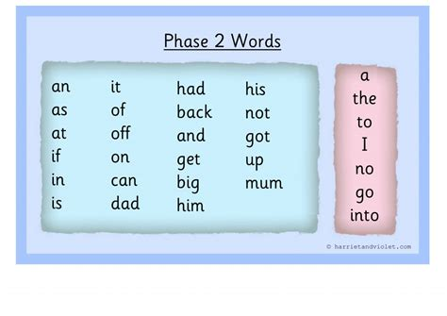

Phase 2 sounds:
Set 1: s, a, t, p
Set 2: i, n, m, d
Set 3: g, o, c, k
Set 4: ck, e, u, r
Set 5: h, b, f, ff, l, ll, ss

Children will have access to magnetic letters and boards so as well as writing words they will also be able to make words.
In F2 phonics is taught 4 days a week and the children are split into groups across the unit based on their needs. The baseline assessment often indicates a group of children that are able to orally blend and recognise 16 or more sounds. This group are able to start phase 2.
Once the majority of a group are secure in phase 2 they move onto the next phase.
Phase 3 is where the children are taught the next 25 phonemes. They are taught digraphs (two letters one sound) i.e sh and trigraphs (3 letters one sound) igh. They are taught to read words and write words with the sounds.
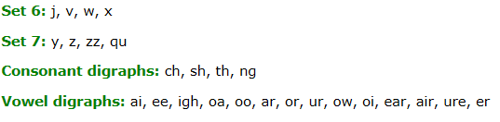
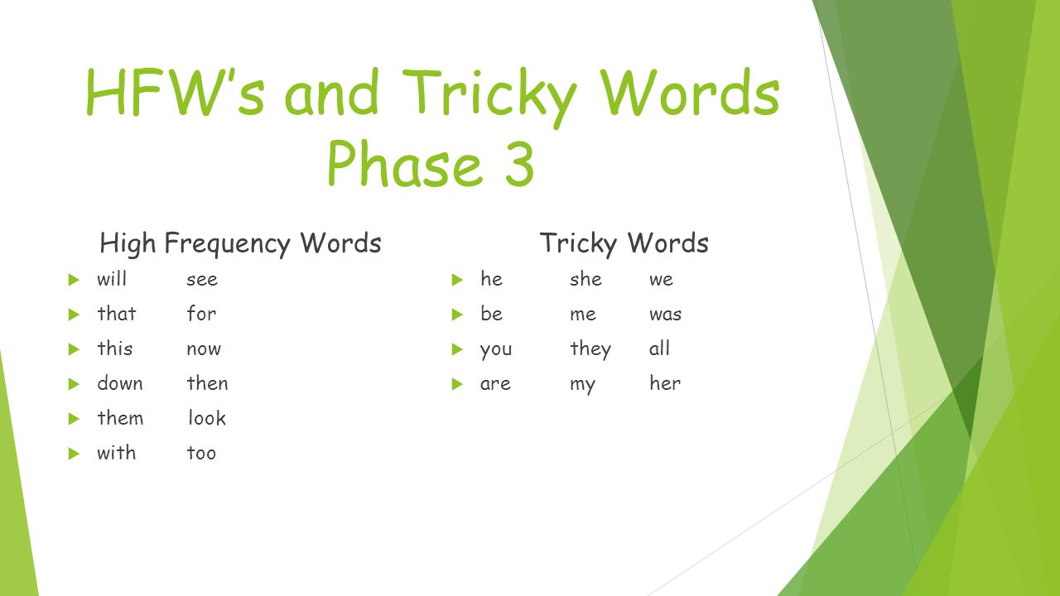

Children are taught a new set of high frequency and tricky words.
The overall aim in FS is for all children to be secure in phase 3 at the end of the year.
There will be some children who are secure at this phase and may have started phase 4.

Content for Key Stage 1

Phase 4 is the phase that children in Year 1 are expected to start with. However, there are groups that need intense revision of phase 3 phonics.
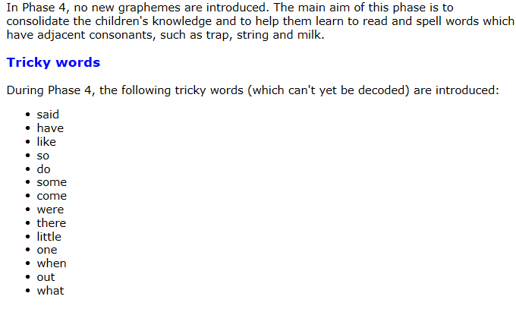

In phase 4 children learn about words with more than one syllable – polysyllabic words.

Phase 5 is a phase that is taught in Year 1. This is one of the trickiest phases as although the children know the sounds, this phase teaches them alternative spellings to those sounds.
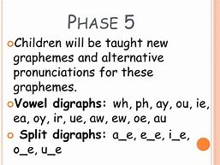

New tricky words taught:
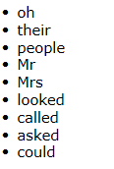
The aim is for children to be secure at phase 5 by the end of Year 1. By the end of Year 1 children should be able to read and write the 100 high frequency words.
Phase 6 is the last phase of phonics and this phase is taught throughout Year 2. In this phase the main aim is for children to become more fluent readers and writers.
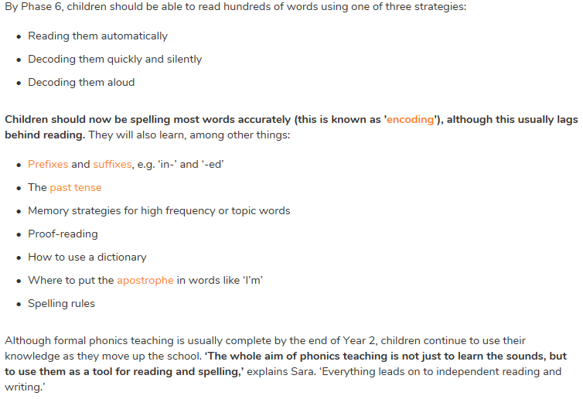
Progression and continuity of key knowledge or skills:

At Kibworth we have a progression chart for the teaching of phonics.
We aim for children to be secure at phase 3 phonics by the end of Foundation Stage, so they are ready to begin phase 4 in the Autumn term of Year 1. Children are expected to be secure in phase 5 at the end of Year 1, so that in Year 2 children have a recap over phase 5 and begin phase 6.

Teaching and learning strategies:

At Kibworth Primary School, we follow the letters and Sounds document’s principles and practice across the EYFS and Key Stage One – this is supported by teachers using elements from Jolly Phonics and Phonics Play to support the effective delivery of phonics lessons by catering for all children’s needs.
Each Phonics lesson should include the following sections:
Revise – Overlearn the previous graphemes and words.
Teach – Introduce a new grapheme / words
Practise – Develop GPCs (grapheme phoneme correspondences) /read and spell new words.
Apply – Use the new graphemes / words in games and activities to secure knowledge.
Assess – Monitor progress within each phase to inform planning.

Links with other curriculum areas – Knowledge and Skills:

Once children can read they can access all areas of learning. Staff in FS and KS1 understand the importance of enabling children to become fluent readers through the teaching of phonics. Children are encouraged to apply their phonics skills in all areas of learning to build up their fluency.

Resources:
Staff who teach phonics create their own resources where appropriate. There is a phonics resource folder in the phonics curriculum folder.

Inclusion: Provision for more able, SEND, EAL etc:

Children in FS and KS1 are placed in phonics groups which are dependent on their phonics knowledge and application. This allows for children to be taught at a pace that is appropriate to their needs. It also allows for the more able children to be extended and those with SEND to have a smaller and multi sensory phonics provision put in place.
EAL children learn well through phonics as they are taught actions to go with the sounds through jolly phonics. They also learn well through the use of pictures to match the sounds.

Equal opportunities:
Every child in FS through to KS1 are taught phonics and given the best possible opportunities to support their journey in phonics.

Assessing progress:

Children’s progress will be monitored using informal assessment i.e. observations and questioning children to identify what they have understood.
Individual phonics assessments will be carried out once children have completed a phase. Each term using scholar pack children are identified as secure or working within a particular phonics phase.

Individual progress is also reported back to parents when phonics assessments have taken place. They are sent home so parents have knowledge of which sounds, and words children can read and spell and the ones they need to work on.

Policy review:

Review Date: | This policy will be reviewed every year by the phonics Lead.  Any suggested amendments will be presented to the Advisory Board for approval.

