**PSHE**

**POLICY**

**December**

**201**

**9**

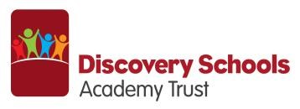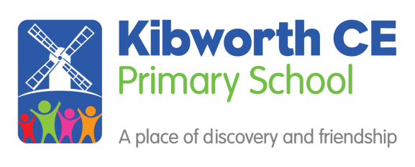

**Kibworth CE Primary School PSHE Policy – December 2019**

**Aims and Purposes**

Personal, Social, Health and Economic Education (PSHE) enables children to become healthy, independent and responsible members of society. Our PSHE Programme promotes the spiritual, moral, social and cultural development as well as the mental and physical development of pupils at Kibworth CE Primary School. We encourage our pupils to play a positive role in contributing to the life of the school and the wider community. In doing so, we help develop their sense of self-worth. We teach them how society is organised and governed. We ensure that they experience the process of democracy in school through the school council. We teach them about rights and responsibilities. They learn to appreciate what it can mean to be a positive member of multicultural society.

This policy is implemented within the context and spirit of the Vision Statement of Kibworth Primary School which values all members of the community equally and respects them as individuals.

“Let your Light Shine”

**The aims of Personal, Social and Health Education are to enable every child to ‘Let their light shine’. All children will:**

* know and understand what constitutes a healthy lifestyle
* be aware of safety issues
* understand what makes for good relationships with others
* have respect for others
* be independent and responsible members of the school community
* be positive and active members of a democratic society
* develop self-confidence and self-esteem, and make informed choices regarding personal and social issues
* develop good relationships with other members of the school and the wider community.

**PSHE and Citizenship Curriculum Planning**

We use the Cambridge Primary Development Programme which includes the strand of Myself and My Relationships, Healthy and Safer Lifestyles, Citizenship and Economic Wellbeing. Toolkits from the Cambridge Primary Development Programme are used to create planning on Sex Education and Relationships (See SRE Policy), Drugs Education, Anti Bullying and Health Education.

We also develop PSHE and Citizenship through activities and whole-school events, e.g. the school council. Representatives from each class meet regularly to discuss school matters. We offer a residential visits to Year 4 and Year 6 children where there is a particular focus on developing pupils’ self-esteem and giving them opportunities to develop leadership and co-operative skills, through team-building activities.

**Early Years Foundation Stage**

We teach PSHE and Citizenship to children of Foundation age as an integral part of the Early Years Foundation Stage Curriculum. We relate the PSHE and Citizenship aspects of the children’s work to the objectives set out in the Early Learning Goals (ELGs). Our teaching in PSHE and Citizenship matches the aim of developing a child’s personal, emotional and social development as set out in the ELGs.

**Key Stage 1**

The Cambridgeshire Primary Development Programme is developed and implemented in phases. In Years 1 and 2 the coverage is shown in the table. The programme also incorporates aspects of the SEAL programme for PSHE.

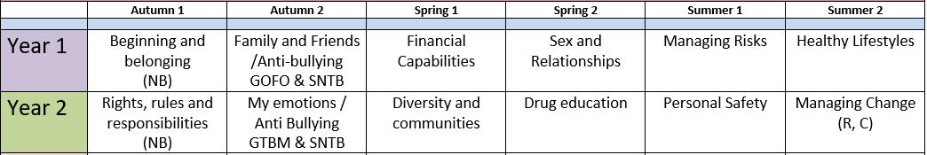

SEAL: NB = New Beginnings, SNTB = Say No to Bullying, R = Relationships, C = Changes.

**Key Stage 2**

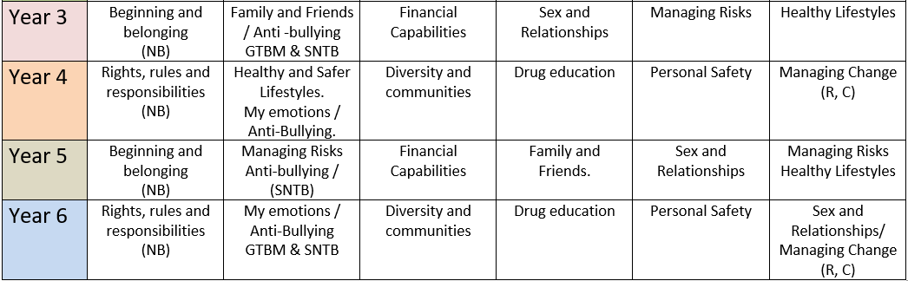

**Teaching and Learning Strategies**

We use a range of teaching and learning styles. We place an emphasis on active learning by involving the children in discussions, investigations and problem-solving activities. We encourage the children to take part in a range of practical activities that promote active Citizenship, e.g. charity fundraising or the planning of special events such as an assembly.

We organise classes in such a way that pupils are able to participate in discussion to resolve conflicts and set agreed classroom rules of behaviour. We offer children the opportunity to hear visiting speakers, such as health workers, police, fire and representatives from our local area, whom we invite into the school to talk about their role in creating a positive and supportive local community.

**Teaching PSHE and Citizenship to Children with Special Needs**

We teach PSHE and Citizenship to all children, regardless of their abilities. Our teachers provide learning opportunities matched to the individual needs of children with learning difficulties. When teaching PSHE and Citizenship we take into account the targets set for the children in their Personal Provision Plans (PPPs) and appropriate social support.

**Inclusion**

All children matter and are given every opportunity to achieve their best. We achieve this by planning which will meet the needs of boys and girls, children with special educational needs, children who are more able, children with disabilities, children from all social and cultural backgrounds, different ethnic groups and diverse linguistic backgrounds. We meet needs of all children by:

• Providing resources that reflect diversity and are free from discrimination and stereotyping,

• Using a range of teaching strategies that are based on their needs,

• Ensuring access to every activity where it is safe and reasonable to do so.

**Links with Other Subject Areas**

PSHE will be taught as a discrete subject in allocated Key Stage PSHE Worship time. It also lends itself to other subjects and will be taught in:

***English****:* skills in enquiry and communication; stories that illustrate aspects of personal and social development; ***Maths:*** counting, sharing and economics; ***Science:*** Drugs, including medicine, sex, health, safety and the environment; ***Design and Technology:*** health and safety, healthy eating, realising that people have needs as they generate design ideas, use of technology; ***ICT:*** communicating with others via e-mail; finding information on the internet and checking its relevance; e-safety; ***History:*** reasons for and results of historical events, situations and changes, events, ideas and experiences of people from the past; ***Geography:*** topical issues concerning environment, sustainable development, land use, study of pupils’ own locality and places in different parts of the world, including less economically developed countries; ***Art and Design:*** reflecting on and responding to ideas and experiences communicated through works of art, craft and design from different times and cultures; ***Music:*** making the most of abilities in playing or singing; issues of cultural diversity, their value and their expression; ***P.E:*** teaching and learning about health and safety, development of personal and social skills through team and individual activities, games and sports; importance of keeping healthy through physical activity ***R.E:*** religious and moral beliefs, values and practices that underpin and influence personal and social issues, and relationships. ***British Values and Citizenship:*** Mutual respect, democracy, Individual Law, Tolerance of belief and faiths.

**Assessment and Recording**

At Kibworth C of E Primary School, we believe that it is important for pupils to have opportunities to reflect on their learning, assessment also increases pupils’ motivation and improves learning as their raised awareness of their development illustrates the value of their learning. In PSHE we believe the most suitable assessment is to compare where a pupil is at the end of a lesson (or series of lessons) in comparison to where they started i.e. the benchmark against which progress is measured, is the pupils own starting point. Teachers will carry out a baseline assessment at the beginning of a lesson (or set of lessons), use AFL strategies throughout to gauge understanding, adapt teaching, promote and maximise learning. At the end of the piece of learning, teachers will measure the child’s progress from the starting point (gathered from drawing, writing or questioning). We have clear expectations of what the pupils will know, understand and be able to do at the end of each year. Pupil’s progress in PSHE is reported annually to parents at Parent’s Evenings.

**Resources**

Year groups have a selection of appropriate resources from the Cambridgeshire Primary Development Programme and SEAL scheme of work. We have additional resources in the library.

**Monitoring and review**

The PSHE and Citizenship co-ordinators are responsible for monitoring the standards of children’s work and the quality of teaching. The co-ordinator supports colleagues in the teaching of PSHE and Citizenship, by giving them information about current developments in the subject and by providing a strategic lead and direction for the subject in the school.

This policy should be read in conjunction with the SRE Policy.