

Talk about and explore 2D and 3D shapes using informal and mathematical language. **SSM**

Compare quantities up to 10 in different contexts, recognising when one quantity is greater than, less than or the same as the other quantity.

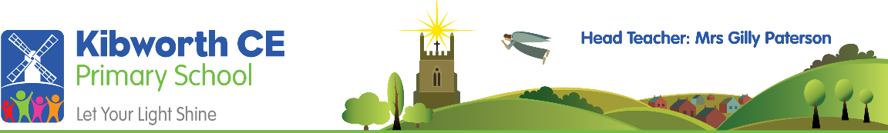

Compose and decompose shapes so that children recognise a shape can have other shapes within it. **SSM**

Create ABAB patterns + correct an error in a repeating pattern. **SSM**

Compare length, weight and capacity. **SSM**

Know one more/one less than numbers to 5.

Subitise amounts up to 5. Begin to recognise larger numbers as ‘5 and …. more’

Recognise different representations of numbers to 10. (including numerals)

Explore the composition of numbers to 10 using manipulatives.

Represent patterns within numbers up to 10, including evens and odds and how quantities can be distributed equally.

Automatically recall some number bonds to 5.

Automatically recall some doubles.

Know one more/one less than numbers to 10 and understand the relationship between consecutive numbers.

Automatically recall some number bonds within 10.

Compare amounts using the language ‘more’ and ‘fewer’.

Carefully count objects to 10 (1:1 correspondence)

To understand position. (through words) **SSM**

Recite numbers to 5.

**Number &**

**Numerical Patterns**

**Progression Map**

Verbally count beyond 20, recognising the pattern of the counting system.

Solve real world mathematical problems with numbers up to 5.

Link numerals and amounts up to 5.

Fast recognition of up to 3 objects. (subitising)

Show finger numbers up to 5.