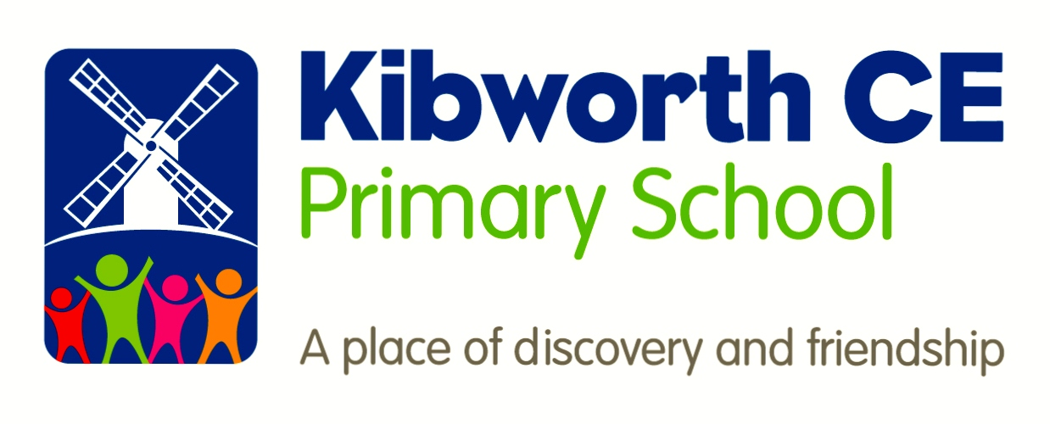

Early Years Foundation Stage Policy
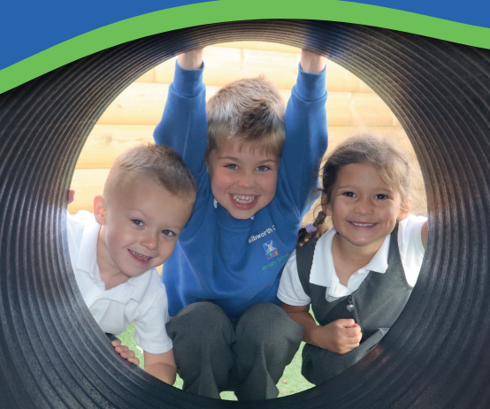

Communication and Language |  | Physical Development |  | Personal, Social and Emotional Development
Literacy | Mathematics |  | Understanding the World |  | Expressive Arts and Design

INTENT
At Kibworth, we have 3 clear aims which are inextricably intertwined with physical, spiritual and mental wellbeing in order to support lifelong learning and future success. We want our children to be:
Successful learners: Children have a positive, confident attitude to learning. They are both physically and emotionally ready to learn. Children are prepared to persevere and stay involved in their learning, even when the process is challenging.
Responsible Citizens: Children show an interest in the world around them. They make a positive contribution to school life and society. Children have a good understanding of diversity and show empathy towards others.
Confident Individual: Children are able to work independently as well as working cooperatively with their peers. Children are reflective learners and are able to talk about their strengths and areas of development.
The curriculum in Early Years is designed to provide a broad and balanced education that meets the needs of all pupils. It facilitates them to gain the skills, knowledge and understanding, as they start out on their educational journey, supporting them to progress from their individual starting points and preparing them for the next stage of their education.
Our ethos in Early Years is to support children’s personal, social and emotional development so that they feel safe and secure and are ready to learn.
Through the seven areas of learning we provide topics that excite and engage children, building on own interests and developing their experiences of the world around them. We recognise that all children come into our setting with varied experiences and all staff work hard to ensure that the learning opportunities provided widen their knowledge and understanding of the world, setting ambitious expectations for all children.
The curriculum celebrates diversity and supports the pupils’ spiritual, moral, social and cultural development. Those children with particular needs, including SEND and EAL are supported appropriately allowing them to be successful.
Implementation
At Kibworth, we offer a curriculum which builds on the knowledge, understanding and skills of all children, whatever their starting points. We follow the Early Years curriculum using topic themes and enrichment opportunities. The children’s interests are also used to help shape our curriculum.
The aim of our curriculum is to develop a thirst and love for learning by:
- Carefully planning sequences of lessons that provide meaningful learning experiences, developing each child’s characteristics of learning and building on prior knowledge.
- Providing high quality interactions with adults that demonstrate and impact on the progress of all children.
- Using high quality questioning to check understanding and address misconceptions.
- Staff acting as role models to the children in order for them to develop their own speaking and listening skills.
- Carefully assessing, through observations, which are recorded on tapestry and shared with parents. These are used to inform the next steps of learning and meet individual needs.
- Developing an effective and engaging environment that is set up so that children can access all areas of learning both inside and outside at any one time.
- Providing child-initiated activities that enhance children’s learning and allow them to apply their learning independently.
- Allowing children to be successful in their attempts at an activity and using effective feedback to help facilitate next steps in learning.
- Suggesting home learning opportunities with information about what has been taught, allowing parents to build on their child’s school experiences, at home.
We recognise the changing needs and interests of our pupils and we are responsive to this, regularly developing existing topics.
In Foundation Stage, the children have a Literacy and Maths whole class taught session 4 times a week and a daily Phonics session. Each child will have an adult led Literacy and Maths activity weekly. In addition, the children have whole class weekly PE, ICT, RE, PSHE and Music lessons.

Outside of whole class and guided group work the children are engaged in continuous provision. continuous provision provides resources, questions and opportunities for self-directed learning and play that builds upon prior learning.
In English we use high quality texts as a basis for Literacy planning. The texts have been carefully chosen with a view to promoting reading for pleasure and linking in with current topics. We also use Talk for Writing techniques to help develop the children’s literacy skills through the imitation of stories and use of actions.
Phonics is taught daily. We follow the Letters and Sounds programme alongside the Jolly phonics songs and actions. Phonics sounds and words are introduced to the children each day in an engaging way. The phonics sounds are constantly revisited to embed over the year and there a range of opportunities for children to apply their phonics knowledge through group activities and continuous provision.
The maths curriculum is taught through dedicated sessions. These sessions are carefully planned to promote early number sense using the fours C’s: counting, comparison, cardinality and composition. This starts with mastering numbers 0-5 and then progresses through to 0-10 and 0-20. We want our children to become confident mathematicians who can problem solve and apply what they have learnt to real life experiences.

Impact
Children demonstrate high levels of engagement in activities, developing their speaking and listening skills, enabling them to access more areas of the learning and communicate to both adults and children. Children develop skills across all areas of the curriculum including literacy, mathematics and physical development using these in different ways.
Children have developed a wider sense of the world around them and can draw on these experiences during interactions with others and link this to new learning.
Children develop their characteristics of effective learning and are able to apply their knowledge to a range of situations making links and explaining their ideas and understanding. Children are confident to take risks and discuss their successes and areas for development with adults, drawing on their experiences to improve or adjust what they are doing.
From their own starting points, children will make excellent progress academically and socially, developing a sense of themselves so that they are well prepared for Key Stage 1.
By the end of Foundation Stage, most children, when assessed against the Early Learning Goals, will be judged as having met the Early Learning Goal. This is termed as ‘expected’ meaning that they have reached the level of development expected at the end of the EYFS. For a list of the Early Learning Goals in each of the areas of learning see Appendix 1.

PARENTS AS PARTNERS

The partnership with parents is vital. We aim to promote positive relationships between staff, parents and children.

We recognise that parents are the child’s first educators and their importance for the child’s welfare and education is paramount.

Each morning, parents are invited into classrooms to do a learning activity with their child. The activity will be short and simple and take around 5-10 minutes. It may involve things such as name writing, spot the difference puzzles, ordering numbers etc. After the activity parents may leave and the children prepare for registration. As well as giving parents ideas on ways to support children at home it is an important time for parents to ask questions or discuss any issues with the class teacher.

In addition, there are also regular opportunities for parents to become involved in school activities such as attending special events, assemblies or volunteering to hear children read. We welcome, encourage and value positive relationship we have with parents.

WORKING WITH OTHERS

We recognise the importance of a smooth transition from home to nursery and from nursery to school. We are building links with our numerous feeder nurseries and make regular visits to meet children in their nurseries before they begin school. We also ensure time to meet with nursery staff to discuss each child in preparation for them coming to school.

Kibworth staff maintain relationships with other external agencies e.g. Health Visitor, Speech and Language Therapist, Educational Psychologist etc in order to improve the provision for all children including those with Special Educational Needs.

MONITORING AND EVALUATION

The policy will be monitored and reviewed in line with the school’s Monitoring and review practices.

The work undertaken will be monitored and evaluated by the leaders with responsibility for the Foundation Stage. This will be in line with the school’s monitoring and evaluation practice e.g. sampling teacher’s planning, samples of work (recorded using audio tape, video tape and written), discussion with children and observations.

Established by: | Gilly Paterson /Katherine Cartwright | Approved Gov:
Revised by: |  | Last reviewed: | September 2020
 |  | Next review due: | September 2021

APPENDIX 1

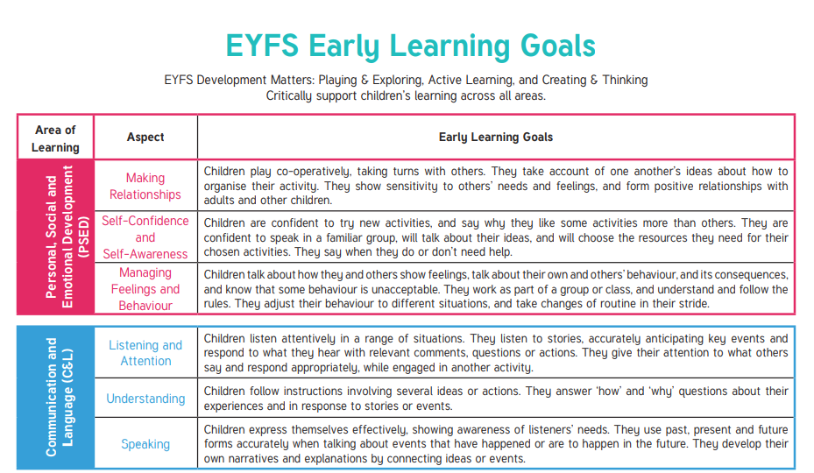
NEW EARLY LEARNING GOALS 2020

