
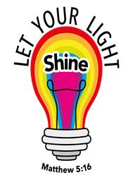
Kibworth Primary School
Year - Foundation: Spring Term 1
Curriculum Information
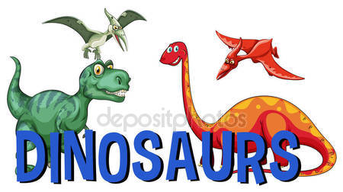

`

Dinosaurs
Dear Parents,
At the beginning of the unit the children will come up with lots of questions about dinosaurs that they would like to find the answers to. The children will be learning the names of some of the dinosaurs and how they were suited to being herbivores or carnivores. Children will also learn about how we know about dinosaurs today by becoming palaeontologists to understand how fossils are made.

Here are some activities we have planned:

Literacy
Reading  - Non-fiction books about Dinosaurs  - Dinosaurs poems  - Dear Dinosaur  - Dear Zoo  - Dinosaur facts | Writing  - Writing sentences about different dinosaurs  - Writing an alternative version of Dear Zoo - Dear Natural History Museum  - Writing a fact card about a chosen dinosaur  - Developing the confidence to attempt independent writing for a purpose  - Beginning to understand and write simple sentences
Phonics  Some children will be continuing to consolidate phase 2 sounds  Others will be starting phase 3 - Introducing - sounds j/v/w/x/y/z digraphs qu/th/sh/ch/ng/ai/oa//ee/oa/oo/  /ow/oi/er/ar/ur trigraphs – ear, igh, air, ure | Handwriting  Continuing to Learn to form letters correctly  Focus on consistent letter size and correct orientation of ascenders and decenders.
Maths
Opportunities will be provided for the children to develop, consolidate and demonstrate their mathematical knowledge, skills and understanding. More mathematical recording will be introduced. The use of mathematical vocabulary for teaching and learning will also be emphasised.
- Exploring the numbers up to 10 – looking at different representations of these numbers, which numbers are fewer/more, how to partition these numbers in various ways, problem solving using these numbers.
- Measure – length/height
- Addition and subtraction
- Problem solving

Understanding The World | Looking at different types of dinosaurs, their similarities and differences. Sorting dinosaurs according to their features.  Role play palaeontologist laboratory. The children will go a dig for dinosaur bones discuss what dinosaur they might be from? Why?
ICT | The children will be continuing to develop their mouse control skills. Beginning to learn how to log on to the computer. Exploring ICT programmes eg maths and phonics activities
Personal, Social and Emotional Development | This half term we will be looking at ‘feelings’. What types of feelings do we have? How do we cope with them? How can we help others to cope with their feelings? We will also look at friendship
RE | We will be looking at different stories from the Bible and exploring their meaning: Noah’s Ark and Jonah and The Whale.
Expressive Arts and Design | Exploring colour and texture of dinosaur’s skin. Painting dinosaurs. Making dinosaur models. Making large scale dinosaur collages, making dinosaur masks.  Music - singing dinosaur songs and looking at pulse/beat
Physical Development | The children will continue to develop their hand/eye co-ordination skills and ball skills as well as developing some simple gymnastic skills. They will also continue to develop their fine motor and cutting skills through a range of activities.

Things that you could do at home
Read lots of information books about dinosaurs
Visit the New Walk Museum or Natural History Museum through a virtual tour
Websites
http://kidsdigdinos.com/dinosaurfacts.htm
http://www.thedinosaurmuseum.com/dino-facts
http://www.bbc.co.uk/cbeebies/games/andys-dinosaur-adventures-game
http://www.bbc.co.uk/cbeebies/shows/andys-prehistoric-adventures
Reading
https://www.bbc.co.uk/bitesize/topics/zdp4382/articles/znc3y9q
Oxford Owl website
http://www.oxfordowl.co.uk/
Listening to your child read really does make a difference! Just 5-10 minutes a night. Asking questions about the story develops their comprehension. Don’t forget to flash card phase 2 and 3 high frequency words daily to help develop your child’s fluency when reading.
Phonics website (phase 2 and 3) (most children are starting phase 3 this term)
http://www.phonicsplay.co.uk/
http://www.letters-and-sounds.com/

Thank you for your continued support,
The Foundation Team

